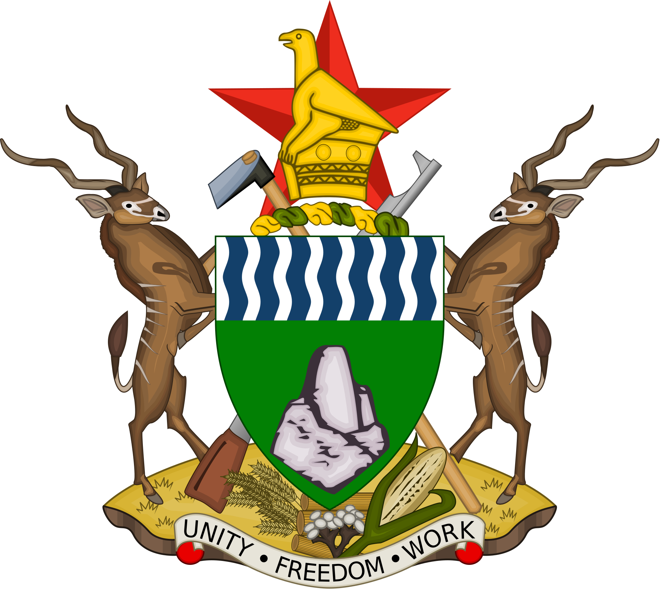

OFFICE OF THE PRESIDENT AND CABINET
CORPORATE GOVERNANCE UNIT (CGU)

PUBLIC ENTITIES CORPORATE GOVERNANCE ACT
[CAP 10:31]

MODEL CODE OF ETHICS FOR SEPS
[PECG ACT – SECTION 26 (2)(b)]

BASIC Code of ethics for

……………………………………………………………
(which is referred to as “the Entity” in this Code)

Introduction
The purpose of this Code is to ensure that the board and staff of the Entity are honest, efficient, competent and accountable.
The general public has a right to expect that the Entity’s board and staff are honest and competent and that they devote themselves wholeheartedly to achieving effective service delivery by the Entity.

Applicability of the Code
This Code is applicable to Members of the Entity’s Board, Executive Management and all Employees

Application of other laws
In addition to this Code, members of the Entity’s board and staff must comply with other laws:

- The Public Entities Corporate Governance Act [Chapter 10:31] sets out their duties, and contains a detailed code of conduct which they must obey.
- The Public Finance Management Act [Chapter 22:19], in section 45, states that employees of public entities must:
  - comply with the entity’s financial management systems
  - ensure that the entity’s resources and assets are used effectively, efficiently, economically and transparently
  - prevent irregular, pointless and wasteful expenditure, and
  - manage and safeguard the entity’s assets.
- The Labour Act [Chapter 28:01] lays down codes of conduct for all employers and employees.

Members of the Entity’s board and staff are expected to read and understand these laws. Copies of them are available at …[state where the Entity keeps copies of these laws for board and staff members to read].

Basic duties of board and senior staff members
Under the Act and this Code, board members and employees owe the following basic duties towards the State, the Entity and its stakeholders and towards each other:

Honesty and integrity
Board members and employees:
- must perform their duties honestly, in good faith and in the best interests of the entity. In their private life also, board members and employees are expected to show integrity and complete honesty
- must be honest and accountable in dealing with public funds, and must use the Entity’s property and other resources effectively, efficiently and only for authorised official purposes.

Duties to the State and Government
Board members and employees:
- must be loyal to Zimbabwe
- must abide by the Constitution and obey the law when carrying out their duties and also in their private lives. If they do not know what the law is, they must take reasonable steps to find out, and
- must co-operate with public institutions established under the law and the Constitution.

Relationship with the Public
Board members and employees:
- must serve the public in an unbiased and impartial way in order to create confidence in the Entity
- must be polite, helpful and reasonably accessible in their dealings with the public, treating members of the public as customers who are entitled to receive high standards of service
- must respect the concerns and needs of the public in performing their duties
- must treat all members of the public with equal respect, regardless of their nationality, race, colour, tribe, place of birth, ethnic or social origin, class, religious belief, political affiliation, opinion, custom, culture, sex, gender, marital status, age, pregnancy, disability or economic or social status
- must not abuse their positions to promote or prejudice the interest of any political party or interest group, and
- must recognise the public’s right to obtain information about the Entity, apart from information that is specifically protected by law.

Relationships with Co-workers
Board members and employees:
- must co-operate fully with other members and employees to advance the public interest and in particular, the interests of the Entity
- must carry out all lawful instructions given to them by their superiors
- must treat their subordinates with proper respect, and must never abuse their authority over them by inducing them to breach their duty to the Entity or to do something against the law
- must not engage in nepotism, i.e. they must not:
  - employ their relatives or friends in the entity or improperly influence or encourage the entity to employ their relatives or friends, or
  - favour relatives or friends in work-related activities
- must use the proper channels to air their grievances
- must not solicit benefits to which they are not entitled
- must deal fairly and professionally with their co-workers, regardless of their nationality, race, colour, tribe, place of birth, ethnic or social origin, class, religious belief, political affiliation, opinion, custom, culture, sex, gender, marital status, age, pregnancy, disability or economic or social status, and
- must not engage in any party political activities in the workplace.

Performance of Duties
Board members and employees:
- must put the public interest first when carrying out their duties
- must do their best to achieve the objectives of the Entity cost-effectively and in the public interest
- must try to be creative in carrying out their duties, seeking innovative ways to solve problems and to increase effectiveness and efficiency
- must be punctual in reporting for work and, except for proper reasons, must work diligently during working hours
- must carry out their duties promptly, professionally and competently
- must keep proper records of what they do, particularly in regard to financial matters
- should try to avail themselves of continuous training and self-development throughout their careers
- must report fraud, corruption, nepotism, maladministration or other conduct which is criminal or prejudicial to the interests of the Entity or the public, and must encourage others to report such conduct
- in the case of board members and senior staff members, must ensure adequate protection for those who report fraud, corruption, nepotism, maladministration or other criminal or prejudicial conduct
- must give their superiors honest and impartial advice, based on all available relevant information, whenever required to give advice
- except when authorised or required by law to disclose it, or when disclosure is clearly in the public interest, must respect the confidentiality of information they acquire in the course of their work with the Entity, and
- in the case of board members, must:
  - be independent in their judgments and actions
  - diligently analyse all proposals placed before the board, and
  - take all reasonable steps to satisfy themselves as to the soundness of all decisions of the board.

Conflict between Official Duties and Private Interests
Board members and employees:
- must not do anything that prevents or hinders them from carrying out their official duties impartially. In particular:
  - they must not give preference to or favour a supplier in exchange for any personal benefit to themselves or their families or friends
  - they must not have a personal interest in any business transaction they conduct on behalf of the Entity
  - they must withdraw from any official action or decision-making process which may result in improper personal gain to themselves
  - they must not use their positions for personal gain
  - they must not engage in any activity that competes with the Entity or interferes with or hinders its activities or business, and
  - they must not take advantage of the Entity’s property or use its property for personal gain or to compete with the Entity.
- must make full disclosure of any personal interest they may have in any decision that is being taken or transaction conducted on behalf of the Entity
- must disclose receipt of any gifts, payments, hospitality or other benefits that are or may be intended to influence or sway their judgement or prejudice their impartiality
- must not make improper use of information they acquire as board members or employees, and
- must disclose their assets fully when required to do so by law
- must disclose to the Board their Directorship(s) on the Board(s) of any other entity(ies), public or private, on which they sit, as well as any shareholding or interest, direct or indirect, they or any associate may have in other entities/companies.

Personal dress and Conduct
Board members and employees:
- when carrying out their duties, must dress and behave in a way that upholds the reputation of the Entity
- must not consume alcohol or other intoxicating substance when on duty
- must act responsibly in the use of alcohol or other intoxicating substances when off duty, and
- must not, whether in their official capacity or in their personal lives and dealings, engage in conduct likely to bring discredit upon the entity.
Compliance with the Code
Every public entity shall appoint a member of its staff to be a “Compliance Officer”.
It is the responsibility of that officer to ensure that, once per annum or upon revision of this Code, every Board Member, every member of Executive Management and all employees of the entity shall acknowledge and provide written affirmation that he/she is aware of the Code and has complied with the provisions thereof.
New Board Members and all new members of staff, at all levels, shall sign such acknowledgement (of awareness of the Code) at their time of their appointment.
Reporting
Whilst it is the responsibility of every Board Member, every member of Executive Management and all employees of the entity to ensure his/her compliance with the Code, all violations of the provisions of the PECG Act, its accompanying Regulations as well as the provisions of this Code must be immediately reported to the Board through the Compliance Officer.

ANNUAL COMPLIANCE CERTIFICATION

CODE OF ETHICS FOR DIRECTORS, SENIOR MANAGEMENT EXECUTIVES AND EMPLOYEES OF STATE ENTERPRISES AND PATRASTATALS AND PUBLICLY-OWNED ENTITIES

I, ................................................................

Do hereby solemnly affirm that, to the best of my knowledge and belief, I have fully complied with the provisions of the Code of Ethics for Directors, Senior Management Executives and Employees of State Enterprises and Parastatals, Publicly-Owned Entities during the Financial Year ending .................................

Signature ........................................................
Name ........................................................
I.D. No ........................................................
Designation ........................................................
Date ........................................................

Witnessed by ........................................................
Name of Compliance Officer ..................................
Date ........................................................

